4/4/2024

Was able to use Cameron’s code to read values off of the moisture sensor from Ada fruit. - Cayden & Chase

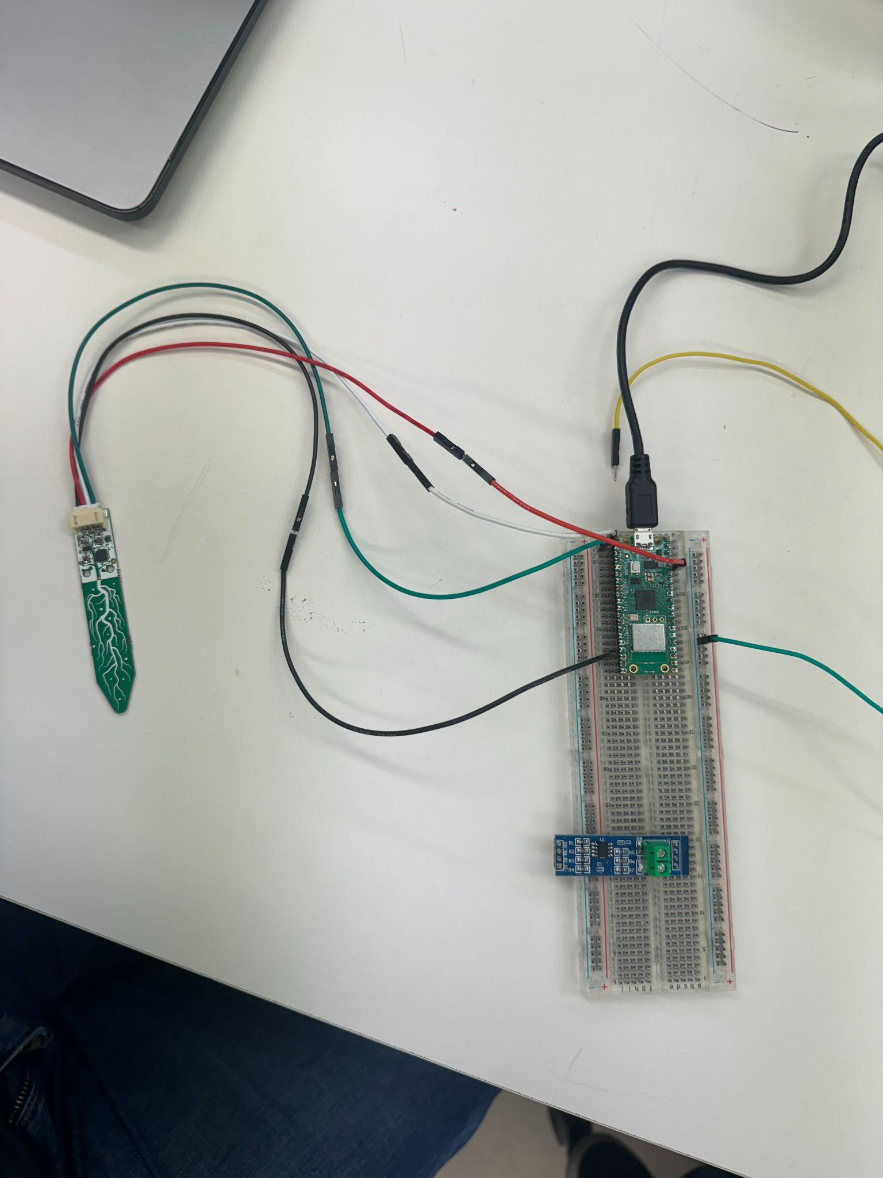



Also validated the operation of a relay with 3.3V VCC and 3.3V Com port from an external power supply. Requires approximately 2ma from the Raspberry Pi to switch it ON. The relay requires 100ma while in the ON state from an external power supply. Cayden’s pump requires approximately 300ma, while Cameron’s pump requires around 80ma of current.

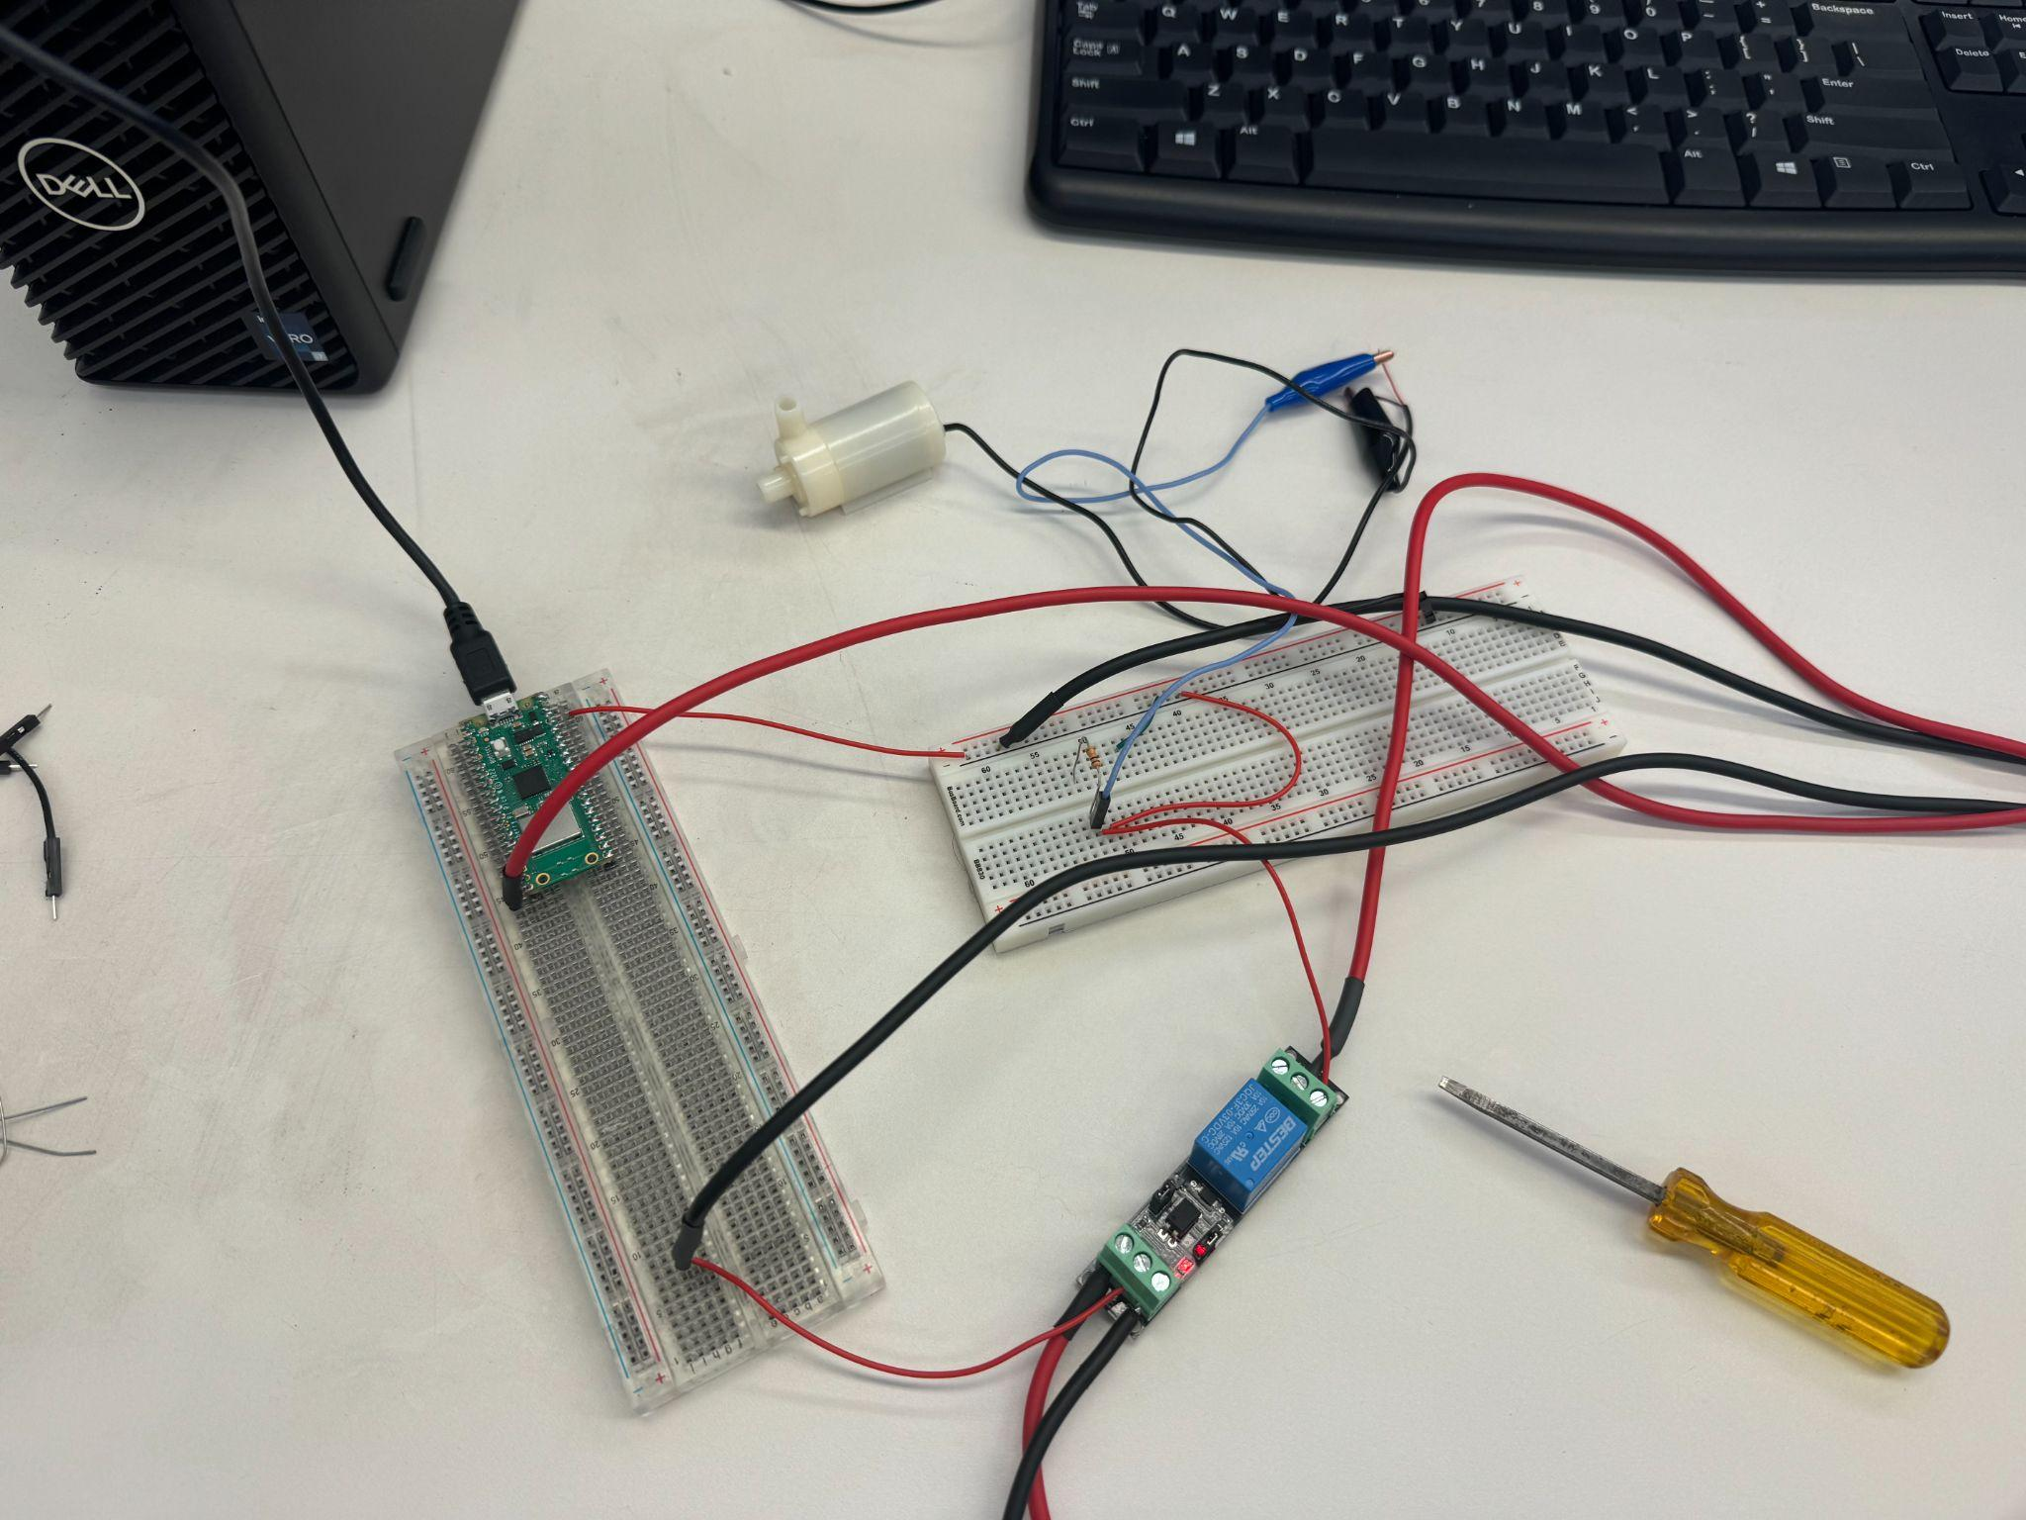

Wrote a very simple script to turn the pump ON and OFF with the microcontroller:

from machine import Pin

from time import sleep

WPump = Pin(15, mode = Pin.OUT) #Corresponds to GPIO port 15, which is pin 20 on the pico w

WPump.on()

sleep(20)

WPump.off()

Pump turned ON and OFF without issues.

Note that the pin call refers to the GPIO port number and no the overall port number.

Relay tested <https://www.amazon.com/dp/B09G65YFZ6?psc=1&ref=ppx_yo2ov_dt_b_product_details>

//Cayden and Chase

Note: I (Cayden) left a 5v rs485 to UART converter in the lab along with a relay for people to use until we purchase other devices.

<https://www.tesrshop.com/blog/soil-npk-sensor-with-raspberry-pi-pico/5>